VTS 区 域 | VHF工 作 程 序
VTS管理服务范围：  台州VTS分成两部分：  - 海门管理服务区： L1报告线以西，椒江大桥以东和下述各点连线及岸线围成的水域：  （1）凉帽屿灯桩;  （2）28°41′06″N/121°47′18″E;  （3）28°41′06″N/121°39′36″E;  （4）28°37′08″N/121°39′36″E;  （5）28°37′08″N/121°47′18″E  2、大麦屿管理服务区：为下述各点连线及岸线围成的水域：  （1）草捆屿灯桩;  （2）小乌岛西侧;  （3）28°06′15″N/121°05′30″E ;  （4）28°01′00″N/121°06′00″E;  （5）28°01′00″N /121°14′36″E;  （6）黄门山（136）  管理和服务的对象：  按有关国际公约和国内规范规定应配备通信设备的一切外国籍船舶、300总吨及以上的中国籍船舶和主管机关要求加入VTS系统的船舶和设施。  管理依据：  台州交管中心依据《中华人民共和国海上交通安全法》、《中华人民共和国船舶交通管理系统安全监督管理规则》、《台州船舶交通管理系统安全监督管理规则》等，在本管理服务区域实施船舶交通管理，提供交通服务。 | VTS 中心工作频道：
 | 区 域 界 限 | 呼 叫 频 道 | 工 作 频 道 | 呼 叫 名 称
 | 海门管理服务区  大麦屿管理服务区 | VHF CH16/CH10  VHF CH16/CH73 | VHF CH10  VHF CH73 | 台州交管中心  台州交管中心
注意：

在VTS管理水域内的所有船舶应在主管机关公布的呼叫频道上保持守听。

台州交管中心通信地址：浙江省台州市椒江区白云山西路26号 邮政编码：318000
联系电话：+（86）-576-88312756

图文传真：+（86）-576- 88312757 电子邮件：tzvts@sina.cn

工作时间：北京时间00:00--24:00

工作语言：汉语普通话、英语
台州船舶交通管理系统用户指南
船 舶 报 告
报 告 类 别 | 报告时间或报告位置 | 报 告 方 法 | 报 告 内 容
航行计划  报告 | 进港：抵港前24h（航程不足24h的，在驶离上一港口时）出港或移泊：出港或移泊前4h（不足4h的，在航行计划确定时） | 书面报告台州交管中心 | 进港报告内容：1.船名和呼号；2.船舶类型；3.国籍；4.抵港最大吃水；5.出发港；6.目的港或泊位（锚地）；7.船长和船宽；8.总（净）吨位；9.预计到达时间；10.载货种类和数量；11.水面以上最大高度；12.其它需要报告的信息  出港或移泊预报：1.船名；2.停泊位置；3.目的港（泊位）；4.预计开航时间
驶入报告 | 驶入VTS管理区域报告线时 | VHF相应频道呼叫台州交管中心 | 1.船名；2.动态
到达报告 | 完成靠泊或锚泊 | VHF相应频道呼叫台州交管中心 | 1.船名； 2.泊位或抛锚时间；3. 锚位
过桥报告 | 过桥前15分钟 | VHF相应频道呼叫台州交管中心 | 1.船名；2.位置；3.载重吨；3.实际最大吃水；4.水面以上最大高度
动态报告 | 抛、起锚或靠、离泊前15分钟 | VHF相应频道呼叫台州交管中心 | 1.船名；2.锚位或泊位；3.船舶动态
移泊报告 | 移泊前15分钟 | VHF相应频道呼叫台州交管中心 | 1.船名；2.预抵泊位或锚地
开航报告 | 开航前15分钟 | VHF相应频道呼叫台州交管中心 | 1.船名；2.位置；3.下一港
驶离报告 | 离开VTS管理区域报告线时 | VHF相应频道呼叫台州交管中心 | 1.船名；2. 动态
水上作业报告 | 作业开始和结束时 | VHF相应频道呼叫台州交管中心 | 1.水上过驳船及卸驳船船名；2.过驳货物名；3. 过驳开始和预计结束时间；4.结束时间、吃水及航行计划
施工作业报告 | 进入或驶离作业水域时 | VHF相应频道呼叫台州交管中心 | 1.施工船名；2.进入和撤离时间；3. 位置
紧急情况  报告 | 发生或发现交通事故、污染事故或其它紧急情况 | 采用一切有效手段报告台州交管中心 | 1.船名；2.位置；3.紧急情况；4.交管部门要求的其他信息
异常情况  报告 | 发现助航标志异常、有碍航行安全的障碍物、漂流物或其他妨碍航行安全的异常情况 | 采用一切有效手段报告台州交管中心 | 1.船名；2.位置；3.异常情况；4.交管部门要求的其他情况
船舶报告线的位置
L1报告线 | 28°43′00″N /121°39′36″E与28°33′00″N /121°39′36″E两点间的连线
Y1报告线 | 黄门山（136）与草屿灯桩两点间的连线
Y2报告线 | 草屿灯桩与横址山灯桩两点间的连线
Y3报告线 | 横址山灯桩与小乌星屿灯桩两点间的连线

引 航 服 务 | 交 通 服 务 | 禁 止
强制引航：  所有外国籍船舶和主管机关规定应当申请引航的中国籍船舶 | 在VTS管理服务水域内，本系统可提供：  - 交通信息（应请求）；  - 气象信息（应请求）；  - 助航服务（应请求）；  - 支持联合行动信息（应请求）；  - 交通组织。  6. 航行警（通）告信息  提供途径：VHF  时间：北京时间  每日00：00--24:00 | - 未经批准禁止在锚地以外水域锚泊，紧急情况除外；  - 未经批准禁止穿越锚地和航道；  - 未经报备禁止在航道、锚地、港池及其附近水域试车、试航、测速、校正罗经和吊放救生艇演习等活动；  - 禁止在航道、锚地、港池及其附近水域从事捕捞、水产养殖以及其他妨碍水上交通安全秩序的行为；  5.未经批准禁止在VTS管理水域内进行水上、水下作业。

TAIZHOU VTS GUIDE FOR USERS

VTS area | VHF working procedures
VTS area:  Taizhou VTS Area is divided into two sectors:  1. Haimen VTS service area: The water with the joint line between the West of reporting line L1 and the East of Jiaojiang bridge and the area jionted by the following five points:  (1)Liangmaoyu light-beacon;  (2) 28°41′06″N/121°47′18″E;  (3) 28°41′06″N/121°39′36″E;  (4) 28°37′08″N/121°39′36″E;  (5) 28°37′08″N/121°47′18″E  2.Damaiyu VTS service area: The water area enclosed by the coast and bounded by a line connecting the following geographical positions:  (1) Caoyu light-beacon;  (2) West of Xiaowu island;  (3) 28°06′15″N/121°05′30″E;  (4)28°01′00″N/121°06′00″E;  (5)28°01′00″N /121°14′36″E;  (6) Huangmenshan（136） | VTS Center working channel:
 | Sector | Calling channel | Working channel | Calling object
 | Haimen VTS service area | VHF CH16/CH10 | VHF CH10 | Taizhou VTS
 | Damaiyu VTS service area | VHF CH16/CH73 | VHF CH73 | Taizhou VTS
Vessels to which system applies:  Ships, which are equipped with the required communication equipments in accordance with the relevant international conventions and/or national rules and regulations, include all foreign flag ships, chinese flag ships of 300 gross tonnage and above, ships and facilities monitored by VTS as required by the competent authority.  General rules and regulations:  Taizhou VTS center controls vessel traffic and provides traffic service within the VTS area in accordance with Maritime Traffic Safety Law of the People’s Republic of China, Safety Management Regulation of Vessel Traffic Service of the People’s Republic of China, Safety Management Regulation of Vessel Traffic Service of the Taizhou Maritime Safety Administration. | Note:  All vessels within VTS area shall keep watch on calling channel specified by the competent authority.  Taizhou VTS center address:  Add: NO.26 West road of Baiyunshan, Jiaojiang District, Taizhou, Zhejiang Province, P.R.China .  TEL: +(86)-576- 88312756 Post code: 318000  FAX: +(86)-576- 88312757 Email: tzvts@sina.cn  Working time : 0000—2400 local time  Working language : Mandarin Chinese and / or English

Ship’s report
Type of report | Reporting time or position | Reporting method | Reporting information
Sailing plan report | For vessels entering the port:  24 hours before arrival (reporting before leaving last port for the voyage within 24 hours )  For vessels leaving or shifting:  4 hours before leaving or shifting  berth(reporting when sailing plan is confirmed within 4 hours) | Via: In writing  To: Taizhou VTS center | Pre-arrival repor:  1. Ship’s name &call sign; 2. Type of vessel;  3. Nationality; 4. Maximum draft;  5. Last port of call; 6. Next port of call or name of anchorage; 7. Length of overall and breadth; 8. Gross (Net) tonnage;  9. ETA; 10. Category and quantity of cargo;  11. Maximum height above water;  12. Any other information needed to be declared  Pre-leaving/shifting report:  1. Ship’s name；2.Berth position；3. Destination；4.E.T.D.
Entry report | When entering VTS report lines | Via: VHF  To: Taizhou VTS center | 1. Ship’s name ; 2.Movement.
Arrival report | After getting berthed or anchored | Via: VHF  To: Taizhou VTS center | 1. Ship’s name；2. Berthing or anchoring time；  3. Anchor position.
Crossing bridge report | 15 minutes before crossing the bridge | Via: VHF  To: Taizhou VTS center | 1. Ship’s name； 2. Position；3.Deadweight tonnage；  4. Maximum draft; 5. Maximum height above water.
Movement report | 15 minutes before anchoring/ heaving up anchor or berth/ departure | Via: VHF  To: Taizhou VTS center | 1. Ship’s name；2.Berthing or anchoring position；3. Ship’s movement.
Shifting berth report | 15 minutes before shifting berth | Via: VHF  To: Taizhou VTS center | 1. Ship’s name； 2. Destination.
Departure report | 15 minutes before sailing | Via: VHF  To: Taizhou VTS center | 1. Ship’s name; 2.Position; 3. Next port of call.
Final report | When departing from VTS area | Via: VHF  To: Taizhou VTS center | 1. Ship’s name; 2. Movement.
Over-water construction report | Right before and after construction | Via: VHF  To: Taizhou VTS center | 1. Name of the ship and barge；2. Name of cargo；3. Estimated time of start and end about transfering cargo；4.End time、draft and sailing plan
Construction report | Entering or leaving construction area | Via: VHF  To: Taizhou VTS center | 1. Ship’s name 2.Entry time and departure time; 3. Position.
Emergency report | When being involved in or finding any traffic accident, pollution incident or any other emergent situations | Via: All effective means  To: Taizhou VTS center | 1. Ship’s name;  2. Position;  3. Emergent circumstances;  4. Other information required by Taizhou VTS
Abnormal report | When finding abnormalities of navigation aids, floating objects, obstacles and other abnormal circumstances impeding the safety of navigation | Via: All effective means  To: Taizhou VTS center | 1. Ship’s name;  2. Position;  3. Abnormal circumstances;  4. Other information required by Taizhou VTS
Reporting line
Report line (L1) | The line connecting the following two geographical positions :(28°43′00″N/121°39′36″E) and (28°33′00″N/121°39′36″E)
Report line (Y1) | The line connecting Huangmenshan(136) and Caoyu light-beacon
Report line (Y2) | The line connecting Caoyu light-beacon and Hengzhishan light-beacon
Report line (Y3) | The line connecting Hengzhishan light-beacon and Xiaowuxingyu light-beacon

Pilotage | Traffic service | Prohibition
Compulsory pilotage:  All foreign flag ships and chinese flag ships required by the competent authority to be piloted | The VTS Center may provided:  - Traffic information (on request);  - Weather information (on request);  - Navigational assistance (on request);  - Information for supporting the allied activities (on requested);  - Traffic organization.  6. Information of navigational warning or notice to marine.  Via: VHF  Time: 0000—2400 Local time | - Anchoring is prohibited out of anchorage area without approval except that is done under an emergent situation;  2．Crossing channel or anchorage is prohibited without approval;  3．Testing main engine, navigation trial, speed testing, calibrating magnetic compass and  launching life boats for drills are prohibited in the channel, anchorage, port basins, and their adjacent waters without approval;  4．Fishing, aquiculture and other actions which may impede the safety of navigation are prohibited in the channel, anchorage, port basins and their adjacent waters;  5．Over-water or underwater construction are prohibited in VTS area without approval.

VTS区域示意图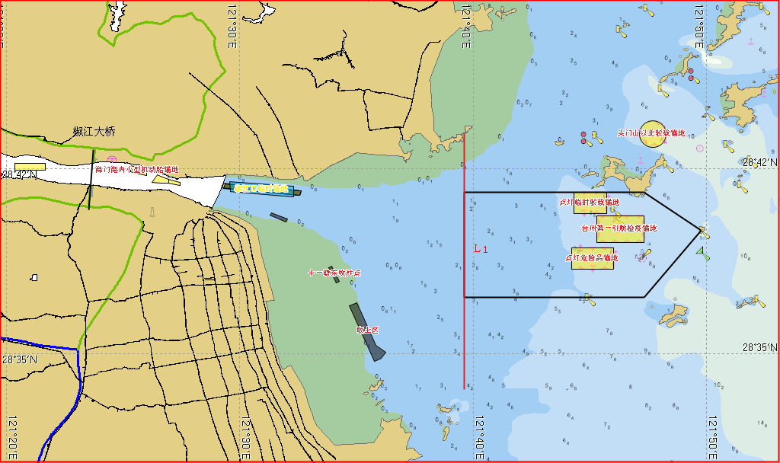

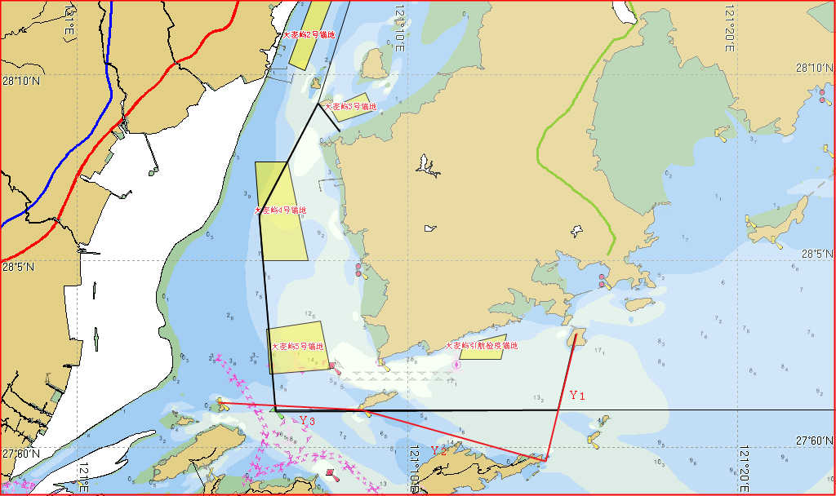
船舶航行计划报告单
Ship Navigation Plan Report
台州VTS:

_________轮预计于___ 年___月___日___ 时，抵/离________ 泊位/锚地，自_____移泊_______

TAIZHOU VTS:
_________(Ship’s name)is expected to arrive at/depart from_________(berth/anchorage) at ______(time),shift from____ _to_____

国籍  Nationality |  | 船籍港  Port of Registry
船舶种类  Type of vessel |  | 呼号  Call sign
起始港  Last port of call |  | 目的港  Destination
船员人数  Number of crews |  | 总吨  Gross Tonnage
主机功率  Main Engine Power |  | 船长  L.O.A
船宽  Breadth |  | 型深  Type Depth
最大吃水  Maximum draft |  | 水面以上最大高度  Maximum height above water
船载货物名  The Goods name |  | 载货量  Quantity of cargo
是否有危险品  Whether Carrying Dangerous Goods |  | 危险品IMO编号  IMO number of Dangerous Goods
本港装货物名称  Name of load cargo |  | 货物数量  The Quantity of Goods
本港卸货物名称  Name of unload cargo |  | 货物数量  The Quantity of Goods
旅客数量  Passenger Number |  | 车辆数量  Vehicle Number
备注 remark：
报告人（盖章）： 联系电话：
Report Man(Seal): Contact：
报告时间；______年____月____日____时
Report Time：

