— 1—

**宁波舟山VTS指南**

**Guideline for Ningbo Zhoushan VTS**

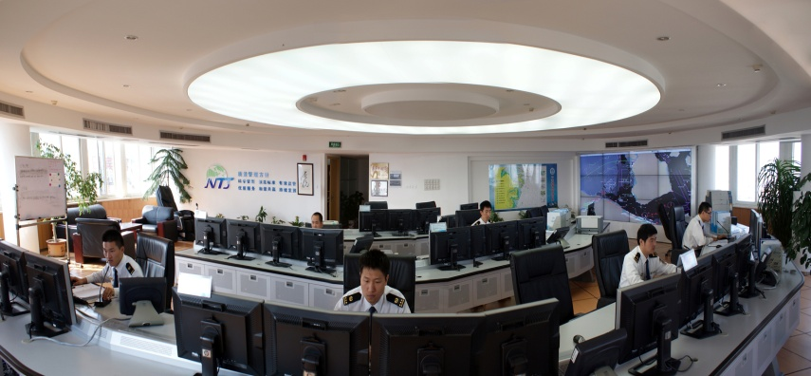

**宁波舟山VTS简介**

VTS系统由宁波VTS中心、舟山VTS中心及北仑山、大榭、峙头、虾峙、游山、大鹏山、穿鼻山、东浪嘴、黄岩头、圆山、尖峰山、马王岗雷达站组成。

**Ningbo Zhoushan VTS Summary**

VTS consists of Ningbo VTS center，Zhoushan VTS Center and Beilunshan，Daxie，Zhitou，Xiazhi，Youshan， Dapengshan，Chuanbishan，Donglangzui，Huangyantou，Yuanshan，Jianfengshan，Mawanggang Radar Station.

**VTS系统构成及性能：**

**The components and functions of VTS:**

1. 雷达监控系统：24海里作用距离，具有跟踪重放功能。

Radar Surveillance System：Effective range of 24miles with automatic tracking,replay function.

1. AIS： 可以自动获得装有船载AIS船舶的交通动态信息。

AIS：automatically acquire the ships’ movement which are equipped with AIS.

3、VHF通信系统：具有多频道录音功能。

VHF Communication System：With multi-channel recording function.

1. 水文气象系统：在北仑山、大榭、峙头、虾峙、游山、尖峰山雷达站全天候实时监测水文气象数据，包括温度、湿度、风向、风速、气压和能见度。

Meteorology System：monitoring meteorology data under all weather conditions in the Beilunshan， Daxie， Zhitou，Xiazhi，Youshan，Jianfengshan in time.

1. 船舶数据处理系统：船舶数据处理能力可达10000个目标。

Ship Data Processing System：Ship data processing capacity is 10000 targets.

6、MIS(管理信息系统)：自动完成船舶过线流量统计，基本实现了值班事件、船舶动态跟踪、数据统计的自动化记录。

MIS( Management Information System)：Automatically count the ship traffic volume of passing reporting line，and record the logbook，ship’s movement tracking， data statistics.

**工作人员在操作 Operator are working**

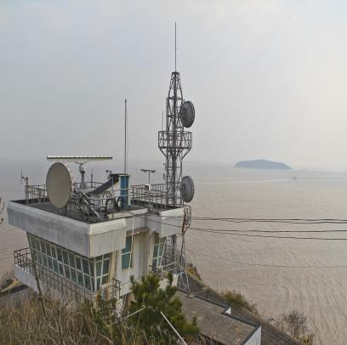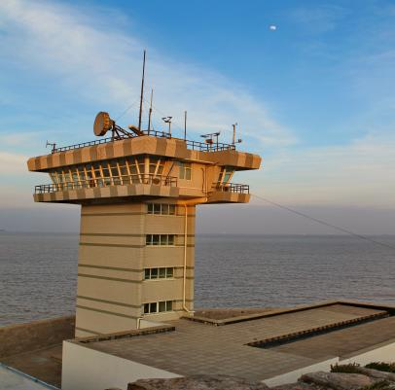

虾峙雷达站 Xiazhi Radar Station 峙头雷达站 Zhitou Radar Station

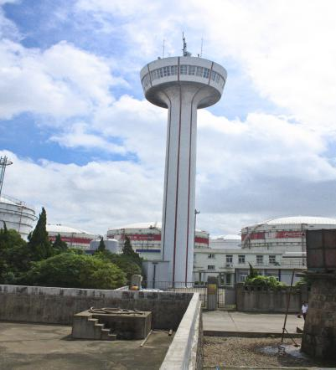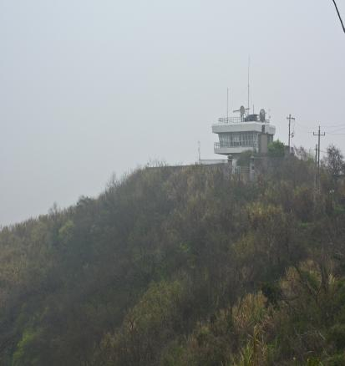

大榭雷达站 Daxie Radar Station 游山雷达站Youshan Radar Station

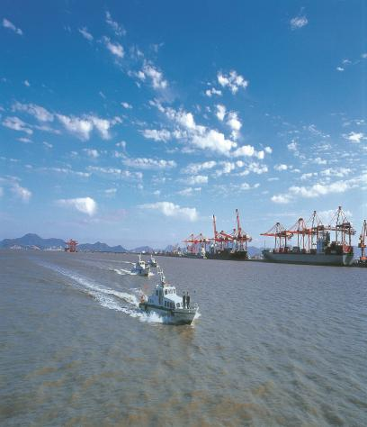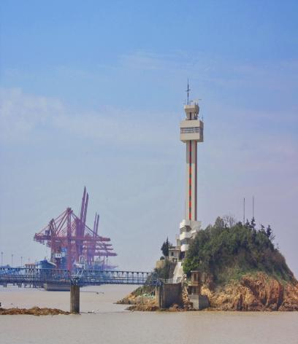

北仑山雷达站 Beilunshan Radar Station 港区 Port area

**系统概况**

**SYSTEM SUMMARY**

**宁波舟山VTS**

宁波VTS中心：

邮政编码：315800

通讯地址：宁波市北仑区 恒山路175号

图文传真：0574-86801546

联系电话：0574-86801531

**Ningbo VTS Center:**

Post code：315800

Add：175 Hengshan Road, Xinqi, Beilun district, Ningbo, P.R.China

Fax：0574-86801546

Tel：0574-86801531

舟山VTS中心：

邮政编码：316000

通讯地址：舟山市定海区盐仓街道螺头社区舟山船舶交通管理中心

图文传真：0580-2263590

联系电话：0580-2607153/0580-2063765/0580-2265163

**Zhoushan VTS Center:**

Post code：316000

Add：Luotou community，Yancang street， Dinghai district， Zhoushan， P.R.China

Fax：0580-2263590

Tel：0580-2607153/0580-2063765/0580-2265163

管理服务对象：按有关国际公约和国内规范规定应配备通信设备及主管机关要求加入VTS系统的船舶。

User：Ships which are equipped with the required communication equipment in accordance with the relevant international conventions and/or national rules and regulations and ships which the competent authority may require to be governed by the VTS.  
管理服务区域：包括7个分区，具体如下：

VTS Area： Includes 7 zones，as follows：

1、第一管理分区：由虾峙门航道小老虎礁灯桩与桃花岛东南侧(29°47′.50N/122°16′.30E)连线以东以及由以下几点连线组成的区域：(a) 29°46′.51N/122°19′.32E;(b) 29°46′.51N/122°34′.90E;(c) 29°34′.50N/122°34′.90E;(d) 29°34′.50N/122°18′.47E;(e) 29°37′.54N/122°13′.97E;(f)六横岛外礁灯桩；（g）虾峙岛东挑嘴（29°44′.68N/122°18′.22E）。其中，虾峙门、条帚门东口外交通组织区由以下几点连线组成：(h) 29°45′.13N/122°20′.22E;(i) 29°45′.33N/122°20′.30E;(j) 29°42′.00N/122°33′.007E;(k) 29°40′.23N/122°33′.01E;(l) 29°40′.23N/122°18′.43E;(m) 29°41′.23N/122°18′.43E。

**Zone NO.1**：The water area formed by the East of the connection line between Xiaolaohu light beacon and SE of the Taohua Dao (29°47′.50N/122°16′.30E)，and the line connecting these points as follow：(a) 29°46′.51N/122°19′.32E；(b) 29°46′.51N/122°34′.90E；(c) 29°34′.50N/122°34′.90E； (d) 29°34′.50N/122°18′.47E；(e) 29°37′.54N/122°13′.97E；(f)Liuheng Dao Wai Jiao light beacon ；（g）Taohua Dao Dongtiao Zui（29°44′.68N/122°18′.22E）.

The water area formed by the following points is the traffic organization zone：(h) 29°45′.13N/122°20′.22E；(i) 29°45′.33N/122°20′.30E；(j)29°42′.00N/122°33′.007E；(k)29°40′.23N/122°33′.01E； (l)29°40′.23N/122°18′.43E；(m)29°41′.23N/122°18′.43E.

2、第二管理分区：东白莲岛新牙咀与升螺圆山岛连线、L2报告线、L3报告线组成的水域。

**Zone NO.2**：The water area formed by the connection line between Xinyazui in Dongbailian Dao and Shengluoyuanshan Dao， L2 reporting line and L3 reporting line.

3、第三管理分区：虾峙门航道小老虎礁灯桩与桃花岛东南侧（29°47′.50N/122°16′.30E）连线、东白莲山新牙咀与升螺圆山岛连线、29°56.′00N/122°05′.95E与涨水潮岛连线、29°56.′00N/122°05′.95E与29°56.′00N/122°10.′00E连线、29°56.′00N122°10.′00E与桃花岛桃花咀连线组成的水域。

**Zone NO.3**: The area formed by the connection line Xiaolaohu light beacon in Xiazhimen and SE of the Taohua Dao(29°47′.50N/122°16′.30E)， the connection line between Xinya Zui of Dongbailian Shan and Shengluoyuanshan Dao，the connection line between the point(29°56.′00N/122°05′.95E) and Zhangshuichao dao，the connection line between the point (29°56.′00N/122°05′.95E) and the point (29°56.′00N/122°10.′00E)，the connection line between the point (29°56.′00N122°10.′00E) and Taohuadaozui.

4、第四管理分区：29°56.′00N/122°10.′00E与桃花岛桃花咀连线以东马峙1号、2号锚地及岙山联检锚地组成的水域。

**Zone NO.4**：The area formed by the east of the connection line between the point(29°56.′00N/122°10.′00E )and Taohuadaozui, Mazhi No.1 anchorage， Mazhi No.2 anchorage and Aoshan quarantine anchorage.

5、第五管理分区：29°56.′00N/122°05′.95E与涨水潮岛连线、29°56.′00N/122°05′.95E与螺头角灯桩连线、、金塘岛宫山灯桩与螺头角灯桩连线、大浦口咀（29°59′.50N/121°50′.30E）与杨公山咀（29°58′.08N/121°47′.70E）连线组成的水域。

**Zone NO.5**: The water area formed by the connection line between the point(29°56.′00N/122°05′.95E)and Zhangshuichaodao, the connection line between the point(29°56.′00N/122°05′.95E)and Luotuojiao light beacon, the connection line between Jintangdao light beacon and Luotoujiao light beacon, the connection line between dapukouzui（29°59′.50N/121°50′.30E）and Yanggongshanzui（29°58′.08N/121°47′.70E）.

6、第六管理分区：由大浦口咀（29°59′.50N/121°50′.30E）与杨公山咀（29°58′.08N/121°47′.70E）连线、L4、L5报告线组成的水域。

**Zone No.6**: The water area formed by the connection line between dapukouzui（29°59′.50N/121°50′.30E）and Yanggongshanzui（29°58′.08N/121°47′.70E）, L4 reporting line, and L5 reporting line.

7、第七管理分区：为下述各点连线及舟山岛、外钓山岛、册子岛、金塘岛、大猫岛沿岸围成的水域：

舟山岛西端（30°10′.00N/121°56′.00E）、小菜花灯桩、金塘岛北端（30°05′.20N /121°52′.40E）、金塘岛宫山灯桩、螺头角灯桩、大猫岛西端（29°57′.2N/122°01′.4E）、螺头（30°00′.00N/122°01′.40E）、老塘山（30°03′.07N/121°59′.07E ）、外钓山南端（30°03′.13N /121°57′.90E）、外钓山北端（30°03′.93N/121°58′.03E）、册子岛东侧（30°05′.43N /121°56′.83E）、册子西灯桩。

**Zone No.7:** The water area formed by the lines connecting these points as follow and the islands such as Zhoushan dao,Waidiaoshan dao，Cezi dao,Jintang dao and Damao dao：

The point west of Zhoushan dao（ 30°10′.00N/121°56′.00E）；Xiaocaihua light beacon；The point north of Jintang dao（ 30°05′.20N /121°52′.40E）；Jintangdao Gongshan light beacon；Luotoujiao light beacon；The point west of Damaodao（ 29°57′.2N/122°01′.4E）；Luotou point（ 30°00′.00N/122°01′.40E）；Laotangshan point（30°03′.07N/121°59′.07E）；The point south of Waidiaoshan（ 30°03′.13N /121°57′.90E）；The point north of Waidiaoshan（30°03′.93N/121°58′.03E）；The point east of Cezidao（30°05′.43N /121°56′.83E）；West of Cezidao light beacon.

工作语言：汉语普通话或英语。

工作时间：北京时间0000-2400。

Working language：Chinese and/or English.

Working time：0000-2400(Beijing time)

宁波舟山VTS中心依据《中华人民共和国海上交通安全法》、《中华人民共和国船舶交通管理系统安全监督管理规则》《宁波舟山核心港区船舶交通管理系统安全监督管理规则》在本管理服务区域实施船舶交通管理，提供交通服务。

Ningbo Zhoushan VTS Center controls vessel traffic and provides consulting service within the VTS Area in accordance with the Maritime Traffic Safety Law of the People’s Republic of China，the Safety Management Regulations of Vessel Traffic Service of the People’s Republic of China，the Safety Management Regulations of Ningbo Zhoushan VTS System.

|  |
| --- |
| **船 舶 报 告 （一）**  **Ships report (一)** |
| **船位报告：**  **Reports on ship’s position:**  **报 告 线：**  **Reporting line:**  L1报告线：桃花岛灯桩与虾峙岛东挑咀（29°44′.68N/122°18′.22E）连线。  Line L1：the connection line between Taohua Island light beacon and Dongtiaozui in Xiazhi Island;  L2报告线：东挑咀（29°44′.68N/122°18′.22E）与六横岛外礁灯桩连线；  Line L2：the connection line between Dongtiao Zui and Wai Jiao  L3报告线：梅山岛小担山（29°46′.11N/121°59′.34E）、汀子山灯桩、温州峙灯桩、鸦鹊礁灯桩与六横岛郭巨山西侧（29°42′.47N/122°04′.17E）连线；  Line L3：the line connecting Xiaodan Shan of Meishan Dao, Tingzi Shan light beacon, Wenzhou Zhi light beacon, Yaque Jiao light beacon and the west side of Guoju Shan in Liuheng Dao  L4报告线：甬江口北导流堤灯桩与长跳嘴灯桩连线；  Line L4：the connection line between the light beacon at the north diversion dike of Yongjiang mouth and Changtiao Zui light beacon  L5报告线：30°05′.20N/121°35′.90E与30°07′.05N/121°49′.25E连线；  Line L5：the connection line between 30°05′.20N/121°35′.90E and 30°07′.05N/121°49′.25E  L6报告线：小菜花灯桩与舟山岛西端（30°10′.00N/121°56′.00E）连线。  Line L6：the connection line between the Xiaocaihua light beacon and the west end of Zhoushan island;  **内 容：**  **Reporting content:**  1、驶入核心港区VTS管理区的船舶，通过VTS报告线时应报告船名、动态、船舶种类、实际最大吃水。  Vessels enter into VTS area should report their names，movements，ship types，maximum draught.  2、从马峙锚地、野鸭山锚地起锚计划通过虾峙门航道、条帚门航道出口的船舶，在进入1号警戒区、7号警戒区前15分钟分别通过VHF14、28频道报告船舶动态。  Vessels from Mazhi anchorage 、Yeyashan anchorage intend to enter Xiazhimen fairway、Tiaozhoumen fairway should report movements in 15 minutes before entering the 1 precaution area、7 precaution area on VHF 14、28.  3、驶离核心港区VTS管理区的船舶，通过VTS报告线时应报告船名和下一停靠港。  Vessels leave the VTS area via the reporting line should report their names and next port of call. |
| **船 舶 报 告 （二）**  **Ships report (二)** |
| **靠离泊报告：**  **Reports on ship’s berthing, departing:**  **内容：**船名、泊位名称。  **Reporting content:** ship’s name ,the name of the berth  **时间：**靠泊后、离泊前。  **Reporting time:** right after getting berthed, before departure;  **抛起锚报告：**  **Reports on ship’s anchoring :**  **内容：**抛起锚时间、锚位名称或位置；  **Reporting content:** the time of dropping or heaving up anchor ,the name of the anchorage position  **时间：抛起锚作业**前30分钟；  **Reporting time:** 30 minutes before dropping or heaving up anchor;  **引航报告：**  **Piloting reports:**  **内容**：（A)船舶动态；（B）引航开始和结束时间、引航员姓名或代号。  **Reporting content :**(A)ship’s movements;(B) time of starting or ending piloting, the name and code of pilot.  **时间**：（A）按主管机关要求；（B）引航开始和结束时  **Reporting time:**(A) required by competent authority;(B) starting and ending piloting  **通过**：在船引航员  **By who:** Pilots on board  **作业报告：**  **Operation reports:**  **内容：**水上过驳受载船及卸泊船船名、过驳货物名称、开始或结束时间。  **Reporting content:** name of big ship and barge, name of barge; starting time and ending time of transferring cargo  **时间**：靠妥卸驳船后  **Reporting time:** right after getting alongside barge.  **活动报告：**  **Action reports**:  **内容：**船名、活动内容、活动范围等  **Reporting content:** ship’s name ,action’s content, scope, etc.  **时间：**活动开始前和结束后  **Reporting time:** Right before and after action  **发生紧急情况报告**：船舶发生或发现交通事故、污染事故、走锚、船员或旅客发生意外、发生对航行安全有影响的设备故障等紧急情况时，报告船名、国籍、时间、地点、原因、经过、故障情况等。  **Emergency reports：** Ships should report their ship’s name, nationality, time, position, cause, course, and breakdown, etc. to VTS if any emergency happens or is found such as traffic accident, pollution, injury of person and breakdown which will affect navigational safety.  **其他报告：**船舶发现助航标志移位、灭失、损坏、失常或其他有碍航行安全的漂浮物、障碍物及其他异常情况时，报告船名、地点、情况类别等。  **Other reports:** Ships should report their ship’s name, position and the abnormal circumstances found to VTS if they find abnormality of navigation aids, obstacles to impede the safety of navigation, floating objects and other abnormal circumstances to impede the safety of navigation. |

|  |  |
| --- | --- |
| **航 路 规 则**  **Route Regulations** | **航 路 指 南**  **Route Guide** |
| 适用船舶：  按有关国际公约和国内规定应配备通信设备及主管机关要求加入VTS系统的船舶。  Application：  Ships which are equipped with the required communication equipment in accordance with the relevant international conventions and/or national rules and regulations and ships which the competent authority may require to be governed by the VTS.  宁波舟山港核心港区深水航路船舶定线制水域：  东起虾峙门口外深水航道东端虾峙1、2号灯浮，止于金塘大桥主通航孔北和西堠门大桥通航孔北；南起外礁灯桩东1.5海里处，贯穿条帚门航道，与起于双屿门响水礁的佛渡水道相汇后延伸至虾峙门航道西口处。由18个分道通航制、2个双向航路、1个深水航道、8个警戒区和若干沿岸通航带组成，全长71.96海里。具体构成及相关规定参见相关定线制。  Deep Water Route of Ningbo Zhoushan Port （area of ship’s routing system ）：  East from light buoy Xiazhi No.1 and No.2 in the east of the deep-water route outside of Xiazhimen estuary, finished up with north of main navigation span for Jintang Bridge and Xihoumen Bridge; south from 1.5 nm east of light beacon Wai Jiao, throughout Tiaozhoumen Channel, extending to the west estuary of Xiazhimen Channel after meeting with Fodu waterways which started from Shuangyumen Xiangshui-jiao.It is composed of 18 traffic separation schemes, 2 two-way routes, 1 deep-water route, 8 precautionary areas and some inshore traffic zones, with a total length of 71.96 nm. Details see the Ship’s Routing System in Ningbo Zhoushan port. | 1、管理区内,大量客运航线和小型船舶习惯航路与主航道交叉。特别在洋小猫、长柄嘴、螺头角、涂泥嘴、上溜网重等及各警戒区附近水域，船舶通航密度大，常有船舶斜穿航道，航经船舶需加强关注，及早联系避让。  There are numerous passenger routes and traditional routes for small vessels crossing the main channel.High traffic and crossing movement always exit in the areas such as Yangxiaomao, Changbingzui, Luotuojiao, Tunizui, Shangliuwangchong, precautionary areas in vicinity. Advise all ships navigate with caution and wide berth request.  2、虾峙门航道特别是在0号警戒区附近水域，渔船较多，航经船舶需谨慎驾驶，宽让远离。  There are many fishing boats in Xiazhimen fairway, especially in the precautionary area No.0 .Advise all ships navigate with caution and wide berth request.  3、虾峙门西口1号警戒区附近为事故多发区。同时，该水域交汇局面复杂，航经船舶要注意加强瞭望，谨慎驾驶，特别注意穿越航道的客船以及马峙锚地、佛渡水道方向的来船。  Maritime traffic accidents occur in the No.1 precautionary area easily. Crossing situation is complex in this area, advise all ships navigate with caution ,especially pay attention to those ferries and ships from the Mazhi anchorage and Fodu waterway.  4、洋小猫岛附近水域时有采运砂船作业，运砂船、渣土船频繁穿越航道，航经船舶需谨慎驾驶，宽让远离。  A large number of small vessels including the sandy and sediment carriers cross the traffic lane frequently. There are also some ships engaging in sandy operation in the waters around Yangxiaomao island. Advise all ships navigate with caution and wide berth request.  5、虾峙门东口、上溜网重、螺头角、涂泥嘴、西堠门、菰茨门等水域流态复杂，特别注意大潮汛期间落水流速较快，航经船舶应谨慎驾驶，与他船及岛屿保持足够安全距离。  Complex current exit in the area such as east of Xiazhi Men fairway ,Shangliuwangchong ,Luotoujiao, Tunizui，Xihoumen,Gucimen,etc. Advise all ships navigate with caution and wide berth request, especially pay attention to the strong ebb tide in the spring tide.  6、虾峙门航道下篮山前后500米航段禁止船舶追越，2万总吨及以上船舶应避免与他船交会。  Overtaking is prohibited in the navigation area 500 meters around the Xialan Shan light pole in the Xiazhi Men traffic lane. Ships of and over 20000 gross tonnages should avoid rendezvousing while navigating in the area mentioned above.  7、条帚门航道：2万总吨及以上船舶避免在黄礁头灯桩前后500米航段与他船交会，第二双向航路水域禁止船舶追越。武港码头有船舶靠泊影响航道附近的船舶航行时，靠泊船舶优先，航行船舶避让等待；离泊时航行船舶优先，离泊船等待。  Ships of and over 20000 gross tonnages should avoid meeting in the navigating area 500 meters around HuangjiaoTou light beacon. Overtaking is prohibited in No.2 Two-way route of Tiaozhou Men traffic lane. Ship berthing at Wugang Terminal has priority over the ships in navigation at the fairway. Ship in navigation at the fairway has priority over the ship unberthing from the Wugang Terminal.  8、通过深水航槽的船舶要遵守《虾峙门口外深水航槽管理规定》。  When navigated in east of Xiazhi Men Deep Water Channel，ship should comply with《Regulations for the east of Xiazhi Men Deep Water route》  9、口外非锚地水域管理：所有进/出口船舶应服从宁波舟山VTS指令在交通组织区内编队进口，并保持安全距离。  Ships should proceed inbound/outbound in order in the traffic organization area by the instruction of Ningbo Zhoushan VTS and keep safe distance. |

|  |  |  |
| --- | --- | --- |
| **交通服务**  **Traffic Service** | **引航**  **Pilotage** | **禁止**  **Prohibitions** |
| VTS中心可提供：  1、交通信息（应请求）；  2、气象信息（应请求）；  3、助航服务（应请求）；  4、支持联合行动（应请求）。  5、播发航行警（通）告信息；  6、交通组织。  **VTS Center can provide:**   1. Traffic information(on request); 2. Weather information(on request); 3. Navigational assistance(on request); 4. Information for supporting the allied activities(on request); 5. Navigation warning(notice) transmitted; 6. Traffic organization. | **引航锚地:**  本港引航锚地为金塘、七里锚地及虾峙门南、北锚地、马峙锚地、口外矿石船锚地、口外油船锚地、岙山联检锚地。  **Pilot anchorage:**  The pilot anchorage of Ningbo Zhoushan port are Jingtang、Qili anchorage and the south and north anchorage of Xiazhimen、MaZhi anchorage、Ore anchorage, Crude oil anchorage, Aoshan quarantine anchorage.  **强制引航:**  所有外国籍船舶和主管机关规定需强制引航的中国籍船舶  **Compulsory pilotage:**  All ships with foreign nationalities and ships with Chinese nationalities required by competent authority to be piloted. | 1. 禁止在通航分道、警戒区、双向航路及其两侧2海里之内从事船舶冲程、旋回性能测试等可能影响其他船舶安全航行的试航活动。   Being engaged in ship-stroke, cycle performance testing and other trial activities that may affect the safety of other ship’s navigation are prohibited in traffic lanes, precautionary areas and two-way routes and within 2 nm on both sides of those above water areas.   1. 除船舶遭遇恶劣气象海况影响或发生事故险情等紧急情况外，船舶不得在交通组织区、航道、港池及禁锚区锚泊。船舶在紧急情况下锚泊时，应立即向VTS报告。   It is prohibited to drop anchor inside the traffic organization zone(east and west of Xiazhimen fairway), channel, port basin and anchoring prohibited area except for emergency. All ships dropped anchor under emergency shall report to Ningbo Zhoushan VTS immediately. |

|  |
| --- |
| **V H F 工 作 频 道**  **VHF working channel** |
| **分区：**  宁波舟山VTS中心VHF通信共分七个区：VHF通信分区划分与VTS管理区域划分保持一致，具体1#-7#分区请参考管理区域划分。船舶在不同的分区内应保持相应VHF频道的守听，经过分区界限时应按规定转换频道。  VHF Zone:  The water areas covered by VHF communications within Ningbo VTS can be divided into 7 zones: Ships in different areas should standby on channels and change channels when passing the boundary line of the zones  1.在1#管理分区内值守VHF08频道；Keep watch on VHF channel 08 in Zone 1.  2.在2#管理分区内值守VHF28频道；Keep watch on VHF channel 28 in Zone 2.  3.在3#管理分区内值守VHF14频道；Keep watch on VHF channel 14 in Zone 3.  4.在4#管理分区内值守VHF71频道；Keep watch on VHF channel 71 in Zone 4.  5.在5#管理分区内值守VHF14频道；Keep watch on VHF channel 14in Zone 5.  6.在6#管理分区内值守VHF06频道；Keep watch on VHF channel 06 in Zone 6.  7.在7#管理分区内值守VHF11频道；Keep watch on VHF channel 11 in Zone 7.  禁止船舶使用VHF06、08、11、14、28和71频道进行与航行安全无关的通话。  It is prohibited to use VHF CH06,08,11,14,28 and 71 for communication which is unrelated with navigation safety.  VHF26:VTS中心将定时或不定时发布相关的安全信息。  VTS Center shall provide related safety information regularly or irregularly on VHF26. |

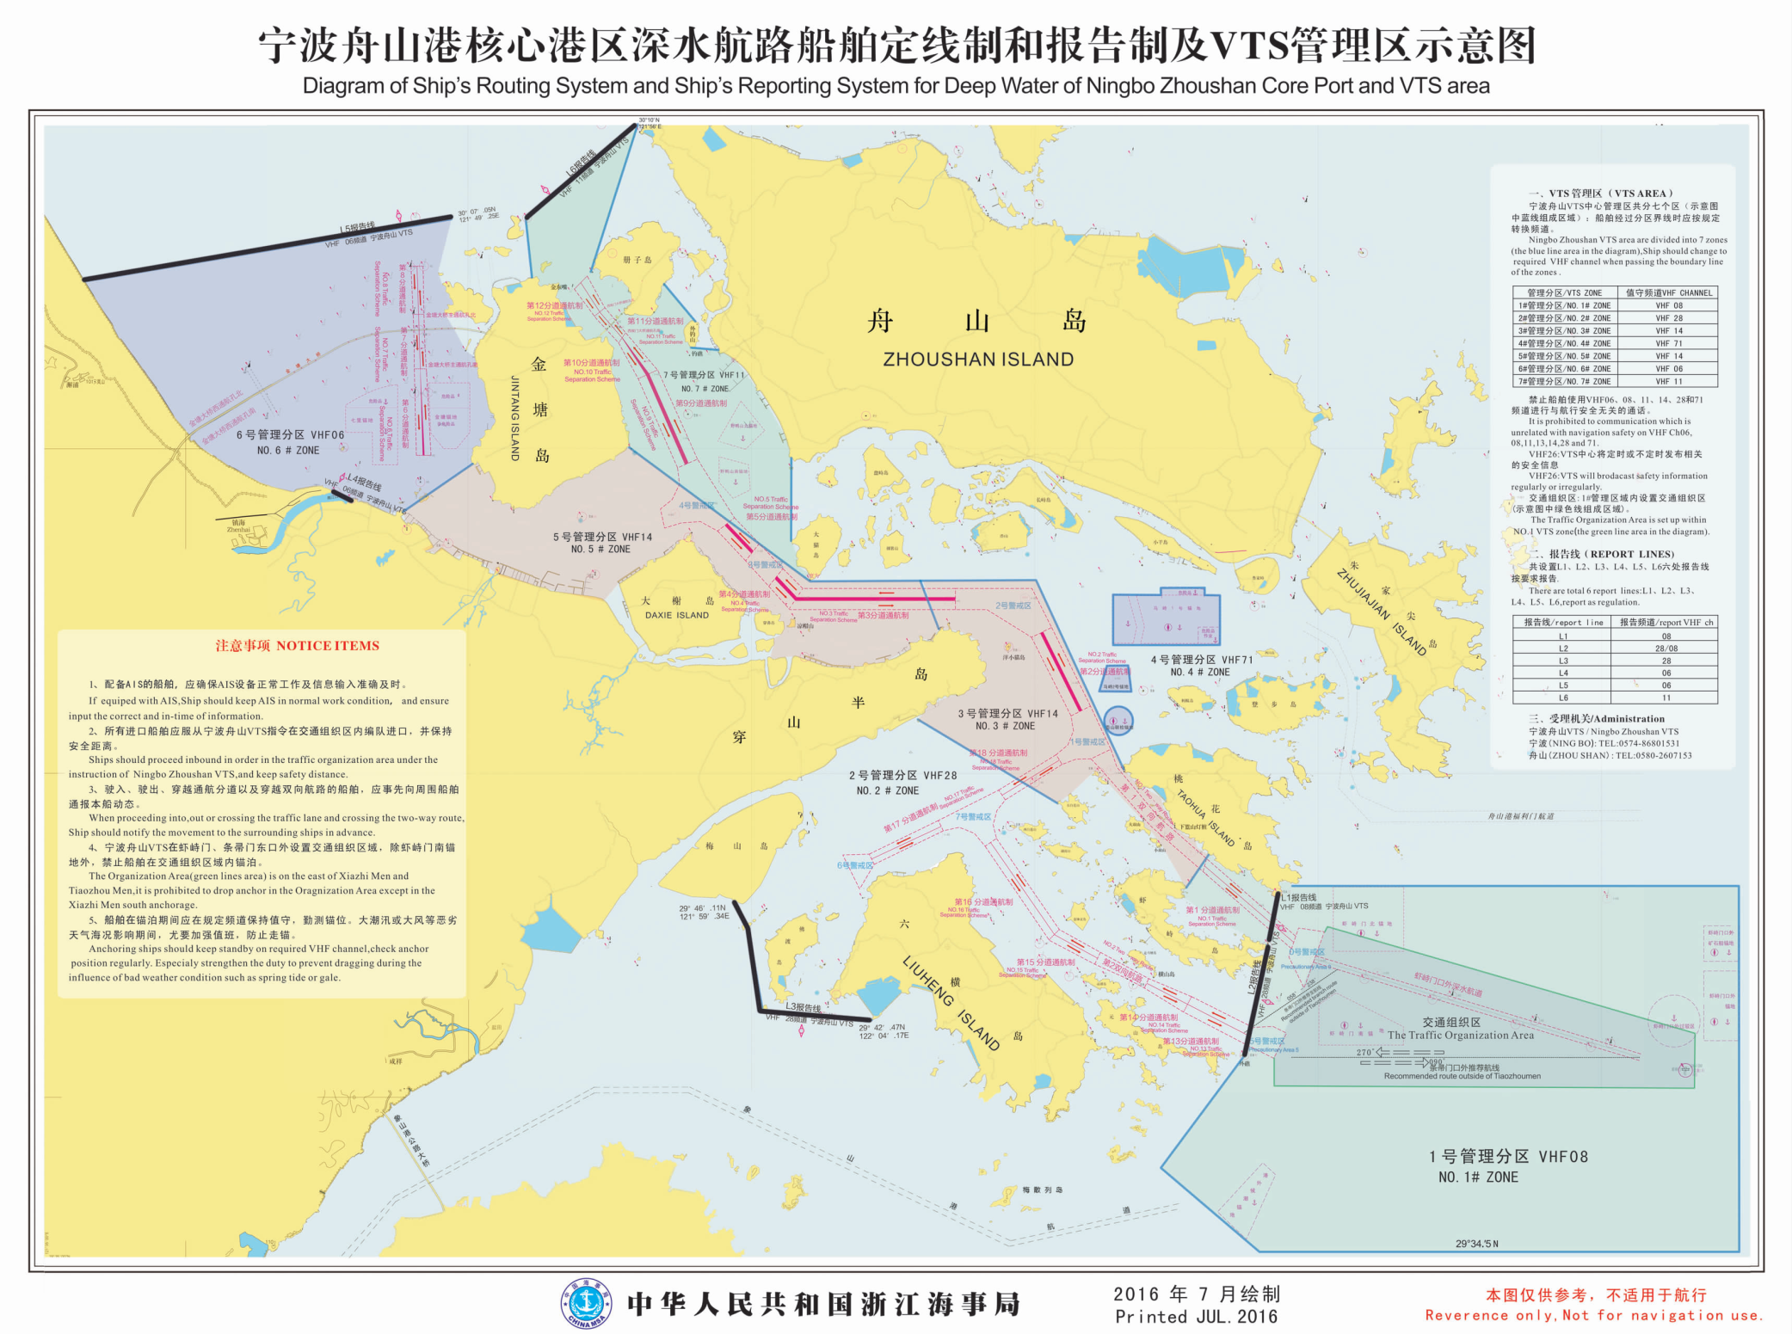

**第一管理分区**

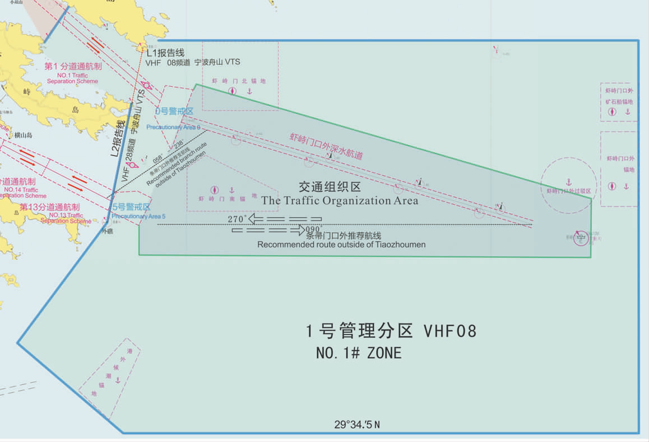

**第二管理分区**

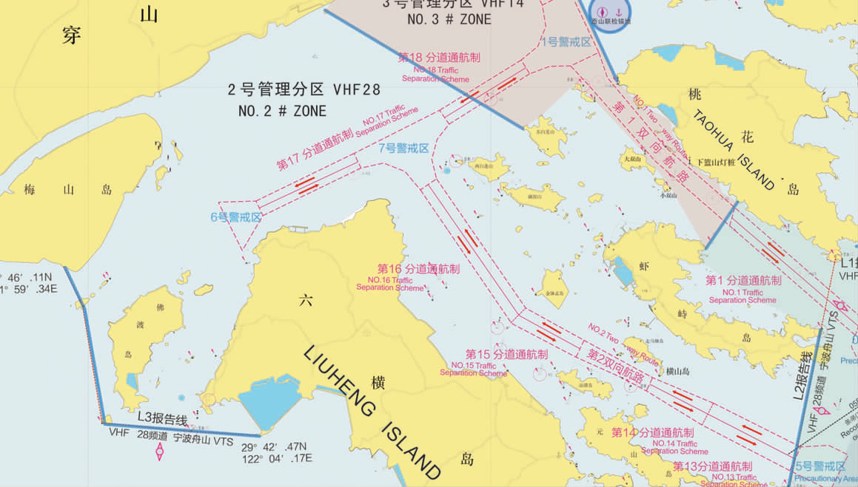

**第三管理分区**

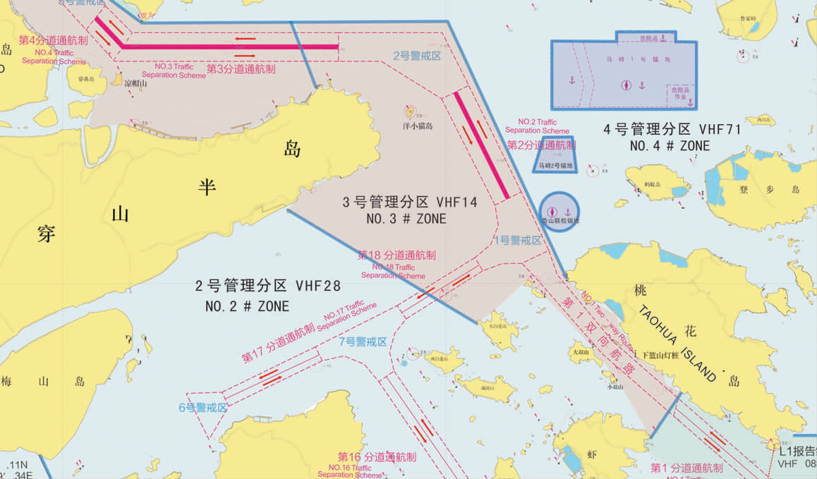

**第四管理分区**

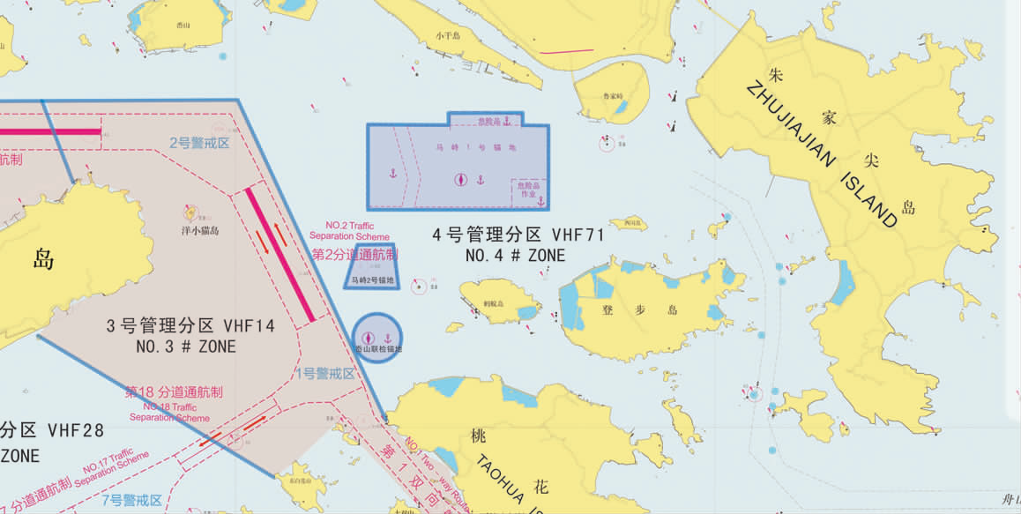

**第五管理分区**

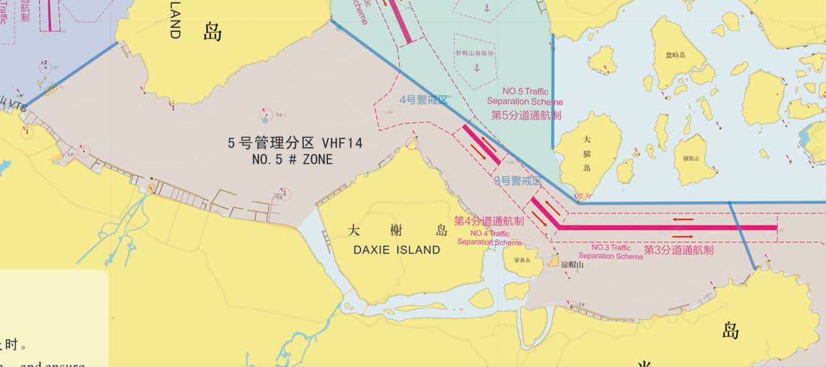

**第六管理分区**

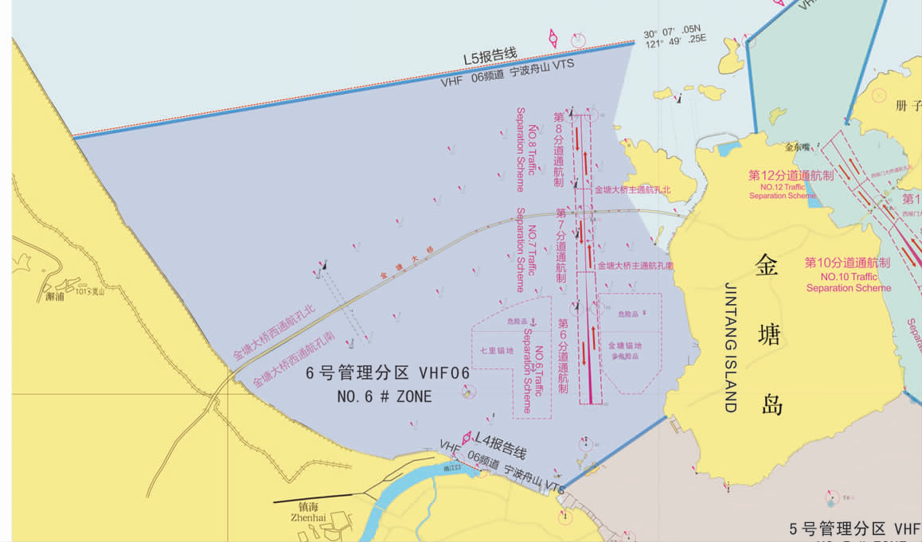

**第七管理分区**

